CASE STUDY: HUMAN RESOURCES MANAGEMENT TRAINING

IMA World Health (IMA) and the Christian Social Services Commission (CSSC), as partners in the USAID-funded Tanzania Human Resources Project (THRP), have been working together with the National Muslim Council of Tanzania (BAKWATA) and the Association of Private Health Facilities in Tanzania (APHFTA) to improve human resources for health (HRH) management by developing and implementing a national level human resource information system (HRIS). The system applies iHRIS Manage software, developed by IntraHealth International, and data are now being actively used to inform HR management decisions on workforce planning, retention, and training for improved productivity and service delivery.

In April 2012, 36 organizational and health facility representatives participated in a workshop on Human Resources Management Training for iHRIS Users. The workshop focused on training these HR managers and leaders about the role that the Tanzanian Human Resource Information System (iHRIS) can play in health workforce management at their organizations and health facilities. The training linked day-to-day human resources management (HRM) activities with tools available from the iHRIS, and provided HR managers and leaders with the necessary skills to apply iHRIS data for human resource management and decision making, and to help them integrate iHRIS tools as part of their daily HR management functions.

When used to its maximum capacity the iHRIS can provide users with data to advocate for additional health workers, budget, plan facility workforce, health worker development, retention, and training, among other issues. Improved human resource management systems have great benefits to both health institutions and the health workers, such as enhanced performance and productivity, improved service delivery, motivation, and retention. All of these things improve the quality of health services and ensure that health services are available to those who need them.

In addition to working with the THRP lead-agency IntraHealth International, IMA and CSSC also linked with the Benjamin Mkapa HIV/AIDS Foundation (BMAF) for the development of this week-long workshop. Understanding that people learn in different ways, these four organizations developed a curriculum that included presentations, group work, role play, and individual assignments.

Content was split into two foci – Human Resources Management, which focused on workforce planning, recruitment, and deployment, health worker retention, career development, performance management, gender, leadership; and iHRIS, which focused on data quality and attributes, utilization, and decision making. The foci of the sessions were integrated by ensuring that the concepts taught in the HRM sessions were applied practically in the iHRIS sessions. For instance, in one of the role plays participants had an opportunity to apply skills learned in the human resource management session on recruitment by role playing the recruitment decision-making process using data and information available from iHRIS.

Participants included both technical and administrative teams. The training was tailored to suit this mixed audience and synergized joint learning among the different teams who all play a key role in supporting the health workforce for quality healthcare service delivery. The mixed teams also allowed for team building to strengthen the relationship between those who are inputting the data and those who use the data in their decision making. Participants left the workshop with increased understanding on the importance of iHRIS and HRM. Several positive workshop evaluations included highlights such as:

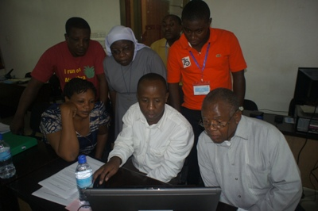
- “Importance of data and effective HRM”
- “Personnel records must be updated and used for day-to-day running of HR departments”
- “Planning”
- “Leaders are Made”
- “How to use data to be a good leader in HRH”
- “Strong data collection and ownership can lead to strong decision making”
HRM training participants using the system for knowledge sharing

- “Professional development and career advancement increase provider competency and motivate workers”

As a component of the training, participants committed to making various changes at their health facilities and institutions to strengthen HRM and iHRIS use and developed action plans. These action plans aimed to improve data utilization, quality, and reporting. In addition to the human resources data within the iHRIS system being utilized to assist facility-level human resource management decisions, it can also be used by higher level public and private health sector institutions to provide HRH information for regulatory and professional bodies to collaborate on national health sector strategic planning.

As a way forward, participants agreed that consistent and effective utilization of the iHRIS would improve and enhance a culture of using human resource data and information for human resource management, leadership, and decision making, thereby ensuring the effective utilization of the health workforce for improved health outcomes.

In looking at the progress since the April 2012 training, facilities have reported that they now regularly update their human resource information and utilize the human resource data and iHRIS reports to inform decisions on promotion, retirement plans, and salary reviews. They also report that information on human resources at some of the facilities is now more readily available and faster to retrieve.

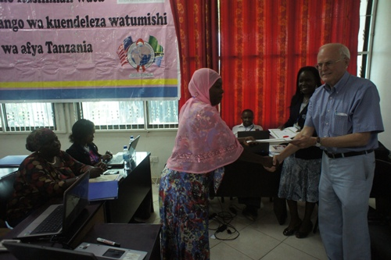
A participant from Cardinal Rugambwa Hospital stated that “since the training I have been able to generate information that is accurate, timely, and adaptable to address new health workforce issues.” Through their (Cardinal Rugambwa Hospital) experience with utilizing the iHRIS, they now have quality data and are effectively using iHRIS to report. As a result, they have been able to better understand the current workforce and plan accordingly for recruitment, training, and retention. The iHRIS has also helped their management team to quickly answer key policy questions affecting health care service delivery. In this facility however, they are affected by other looming health workforce challenges such as shortage of skilled and experienced staff, retention challenges, and high cost of living, among other economic factors. They intend to press on despite these challenges, saying that “the fruits of the iHRIS training can be seen in our facility. By using the scarce resources we have, we are trying to motivate them [health workers] by any means in order to satisfy them and improve the health service delivery”.
Participants receiving their Certificate of Completion after the HRM workshop

System benefits have also been reported by the Association of Private Health Facilities in Tanzania (APHFTA) by improving coordination of their members and utilization of human resources data through follow-up with zonal offices. High staff turnover has however been a challenge for them, which impacts both institutional memory and the technical ability to support their affiliated health facilities.

Bumbuli Hospital reported that since the training, information on employee data is now systematically stored and can be easily retrieved. However, they also note that unreliable Internet connectivity and challenges with inconsistent power supply affect access and retrieval of iHRIS data and information. They suggest modifications to the iHRIS system so that it can also function without Internet connectivity.

Management Sciences for Health, 2005. Human Resource Management Rapid Assessment Tool for Public and Private Sector Health Organizations; A guide for Strengthening HRM Systems, Baker Printing, USA

