Republic of Uganda

Integrated Human Resources Information System (iHRIS)

HRIS Train User’s Manual

November 2013
List of Abbreviations and Acronyms

CD : Compact Disk
CPD : Continuous Professional Development
CSV : Comma Separated Values
DHO : District Health Officer
DVD : Digital Video Disk
GPL : General Public License
HMIS : Health Management Information System
HPCs : Health Professional Councils
HR : Human Resource
HRD : Human Resource Development
HRHIS : Human Resource for Health Information System
HRIS : Human Resource Information System
HRM : Human Resource Management
HRM : Human Resource Management
iHRIS : Integrated Human Resource Information System
IPPS : Integrated Personnel and Payroll System
IT : Information Technology
LAN : Local Area Network
iHRIS-CD : Multimedia CD-ROM with e-learning for iHRIS
MoES : Ministry of Education and Sports
MoH : Ministry of Health
OPEN MRS : OPEN Medical Records System
PPO : Principal Personal Officer
Train : Training Information System
UCP : Uganda Capacity Program
UHSSP : Uganda Health Systems Strengthening Project
USAID : United States Agency for International Development
WB : World Bank
WHO : World Health Organization

Uganda Capacity Program
Table of Contents
1 Introduction 1
1.1 Background 1
1.2 iHRIS Train Architecture, Data flow, and Use 2
1.3 Accessing HRIS Train 3
1.3.1 Log in 3
1.4 HRIS Train Modules and Features 4
2 Manage People 5
2.1 Add Person 5
2.2 Add Individual Information 6
2.2.1 Add Passport Photo 6
3 Manage Trainings and Trainings Providers 8
3.1 Find Training Provider 8
3.2 Add Training Provider 9
3.3 Add Training 9
3.4 Schedule training 10
3.5 View Trainings 11
3.6 Add participants to training 12
3.7 To Add fees 13
3.8 Adding Person to Training via person page 14
3.9 Adding Many Participants to Training from Spread Sheet 16
4 Search Records 17
4.1 Search People 17
4.2 Search Training Provider 18
5 Reports 20
5.1 Tabular report formats 21
5.2 Graphical Report Formats 23
5.3 Report Views 23
5.3.1 Create a new report 24
5.3.2 Edit an existing or created report 25
6 Administer Database 27
6.1 Add Academic Level 28
6.1 Add Training Classification/Cadres 28
7 Administering Users 30
7.1 User Roles 30
7.2 Add a User 30
7.2.1 Self Service 32
7.2.2 Update a User 32
7.2.3 Change Your Password 33
7.2.4 Retrieve a Forgotten Password 34
7.3 Log Out 34

Introduction

Background
The integrated Human Resource Information System (iHRIS) is a computerized Human Resources (HR) management tool consisting of electronic databases for storing, reporting, and analyzing that enables to design and manage a comprehensive HR strategy. It links all HR data from the time professionals enter pre-service training to when they leave the workforce. It is built on free, open source software distributed under the General Public License (GPL), to minimize maintenance costs and ensure sustainability.

The overall goal of the computerized iHRIS is to contribute to better management of workers to ensure to availability of the right number of the workers with the right competencies, in the right place, doing the right job at the right time. The objectives of the iHRIS are to:
- Improve timely availability of accurate and up to date HR data for policy, planning and management.
- Track the workforce as they move through the training/education and employment system
- Increase efficiency in the management and maintenance of Workforce data
- Strengthen coordination of trainings of workers, reduce on duplication, and improve equity.
- Quicken information flow and facilitate regular reporting on the workforce

iHRIS benefits Ministry of Education and Sports (MoES), Ministry of Health (MoH), and stakeholders by supporting the ministry to increase efficiency by strengthening the management of human resource (HR) data through tracking the persons from the time they enter pre-service training, those undergoing different in-service and pre-service trainings, annual performance of students, training opportunities available, graduation times, and tracking deployment of workers in different organizations to reduce on duplication and improve equity.

This is being achieved through deployment of iHRIS that is enabling HR managers at different levels to collect, manage, and analyze HR data (bio-data, training details, employment history and status, staffing levels in organizations, and where employees are deployed) to facilitate in the management of training programs and trainees including the entry, pipeline and graduation details by program area and linkages with each training institution for both in-service and pre-service training.
There are five components of the iHRIS designed to support the key HRH functions of planning (iHRIS Plan), training (iHRIS Train), regulation - qualifications, registration and licensure (iHRIS Qualify), management (iHRIS Manage) and retention of the health workforce (iHRIS Retain).
iHRIS Manage is a human resources management system that enables HR managers to collect , manage, and analyze data on HR about employees’ history, bio-data, employment status, staffing levels, and where employees are deployed . Using the system, the HR manager can create a hierarchy of positions for an organization based on standard titles, job classifications and job descriptions, even spread over diverse geographic locations, offices and facilities. The HR manager can then hire employees to fill each open position and maintain a searchable database of all employees, their skills and qualifications. The HR manager can track each employee's history with the organization, including their performance, training and salary history, and record the reason for departure when the employee leaves.
iHRIS Qualify is the system that capture and aggregate data on a cadre of health workers from the time they enter pre-service training through registration and licensure. It can also track deployments, issue licenses for private practices and out-migration. Thus, it provides a complete country-level picture of health workers, whether in training or employment in the public or private sector. The data captured by iHRIS Qualify can be used by policy-makers to determine: How many trained students pass the certification/accreditation exam? Of the students who pass the exam, how many register to practice? and Are health professionals meeting their continuing education requirements.
iHRIS Train captures analyses data on training programs and trainees including the entry, pipeline and graduation details by program area; and information on training institutions for both in-service and pre-service training. It helps to track progress on curriculum implementation, performance of students, training experience of individual health workers, tracking of credit hours for renewal of license among other things. It also provides information on training opportunities for health workers. This system facilitates coordination of training of health workers, reduction of duplication, and ensuring equity.
iHRIS Plan uses data from above iHRIS system as well as other sources of HR data to project workforce changes in the future based on known factors such as attrition and the number of trained health workers annually entering the workforce..

iHRIS Train Architecture, Data flow, and Use

iHRIS Train has two subcomponents – in-service training and pre-service training. The development of the HRIS Train In-service training subcomponent was primarily guided by the MoH in consultation with other stakeholders. It is hosted by the MoH, with links to professional councils, districts, key institutions, and programs providing in-service training.

The development of the HRIS Train pre-service subcomponent was guided by the MoES in consultation with other stakeholders. It is hosted by MoES with links to training institutions and examination boards.
iHRIS Train was developed to respond to information needs in the management of training of health workers in Uganda, and focuses on:-
- Training courses: types, content, schedule, length of training, target group, and how conducted including methods used and contribution to continuous professional development (CPD)
- Organizations/institutions carrying out training, and training provided, sources of funding for training
- Management of training by organizations like MoES, MoH, HPCs, HMDC, HRD, districts
- Competencies needed for/or to be acquired in relation to the training
- Profiles of trainees - their bio-data, qualifications, and place of work
- Tracking attendees of various courses and timing
- Cost of training
- Performance of trainees

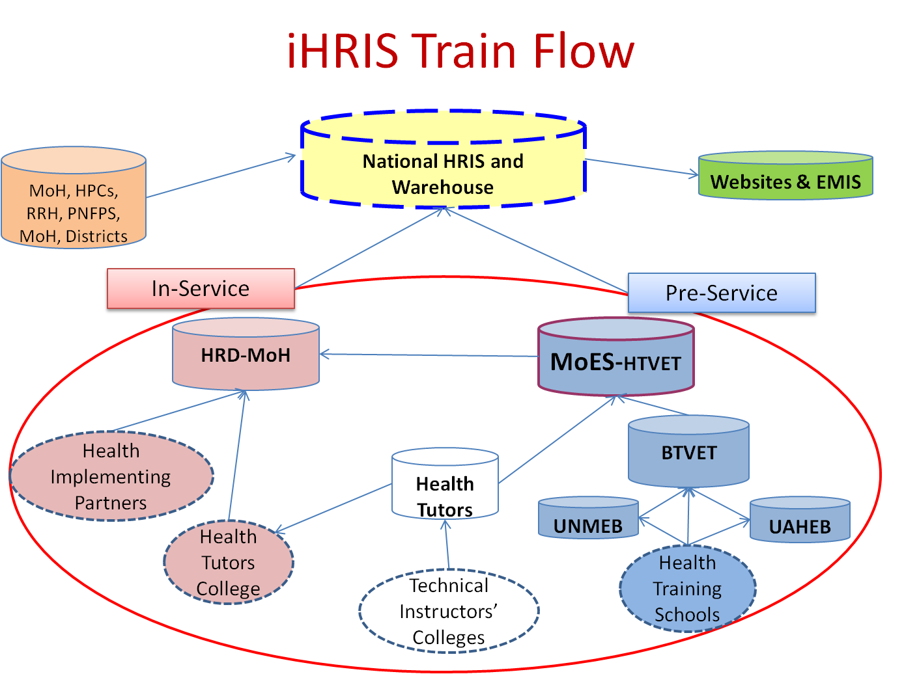

Accessing HRIS Train

HRIS Train is a database management system which can be accessed on LAN or Internet. The system is located on the ministry servers http://hris.health.go.ug and it is accessible by going to section of training, then selecting In-Service Training. For the pre-service, it is available at MoES

Log in
To gain access to the system, you must have a user account. Type your user name and password and click login (see figure below)
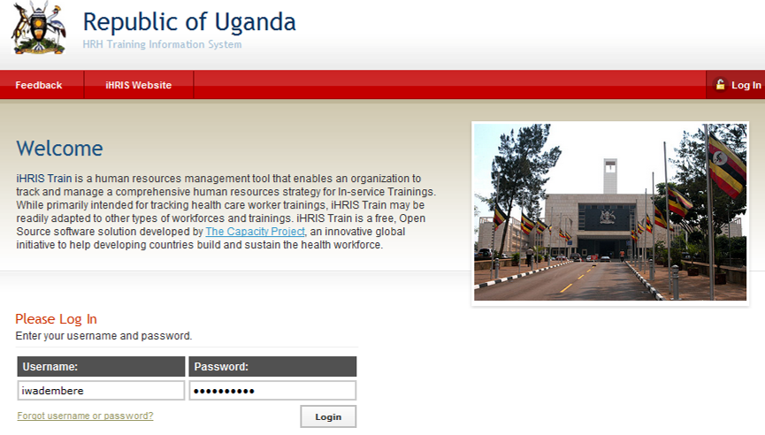
Enter username and password and click on login
Note: If you do not have a user account, contact your System Administrator. To create accounts into the system see section Administer users.

HRIS Train Modules and Features

To get started using iHRIS Train, please click one of the options as explained below
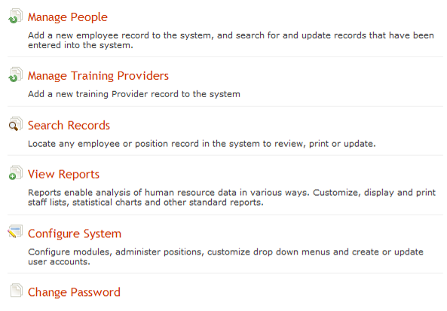

Manage People
Click Manage people to add new persons’ details into system.

Add Person
To track a person in the database, add a record for that person by clicking the Add Person under manage people
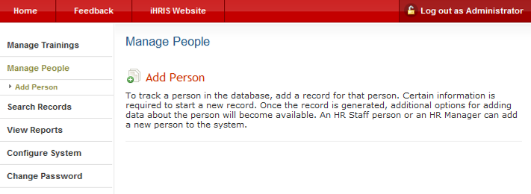
Click on add person to enter details of new person
You will get the input screen as below
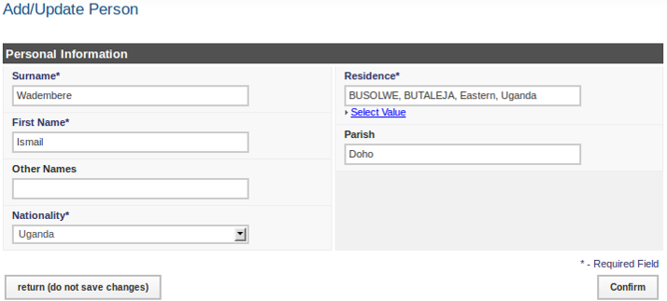
Click on select value to pick the district. Under each click on the arrow of the left to spick the sub-county
Enter the person's Surname, First Name and any Other Names in the appropriate fields. Select the person's Nationality from the dropdown menu. Click on “Select Value” to choose the name of the person's country, region, district, sub-county of residence under Residence. Type the parish where the person comes from.
Click Confirm, the data that you just entered will appear as below.
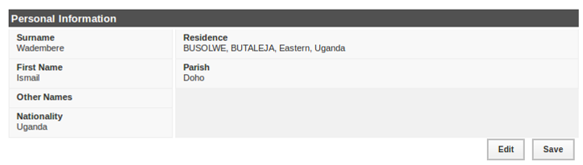
Click edit in case you want to modify data
Confirm that the information entered is correct. If it is not correct, click Edit to change it. If it is, click Save to save it. The person's new record opens with options to add additional information divided into sections.
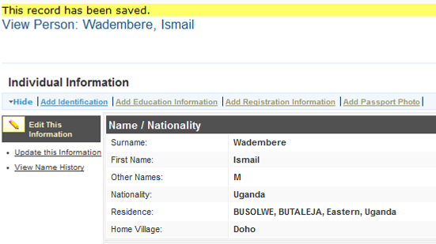
Note that you can click the Hide/Expand option at the top of any section to hide or display that section. You can edit or update a person's record at any time by searching for the record
Click here to add passport photo of person
Click on this to add education background

Add Individual Information
Immediately after a person has been added to the system, the person's record displays, the next step is to add identification, add demographic information, add education information, add passport photo, contact information, and trainings. All are entered using the same steps as demonstrated below when adding passport photo

Add Passport Photo
Click Add passport photo tab under the individual information to get the window below
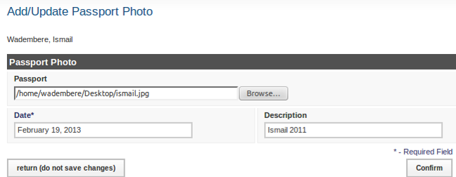
Click here to select a saved photo on your computer

Click Confirm, to get the screen as below
Click here to save
Review the information, if it ok then and click save
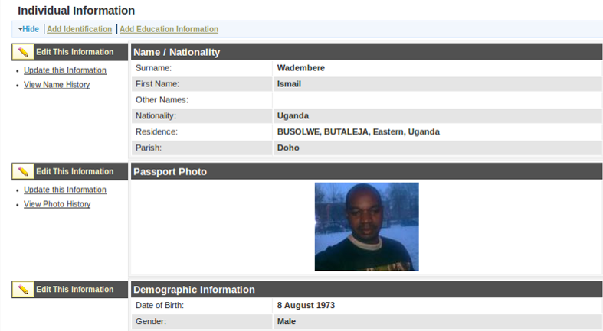
To make changes to information already saved, Click Update this information

Manage Trainings and Trainings Providers
Click on Manage Training Provider to get the window below which enables to add a new training provider, find training provider where trainings can be created, administer training courses, and Training Instance Calendar
Click manage trainings to work with tranings and institutions
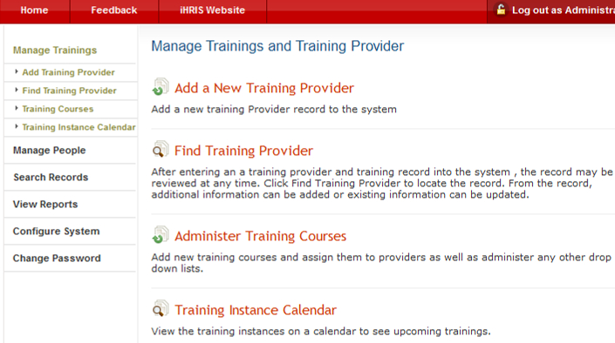
Click here find a training provider

Find Training Provider
To work specific Training Provider, click find training provider, to get figure below
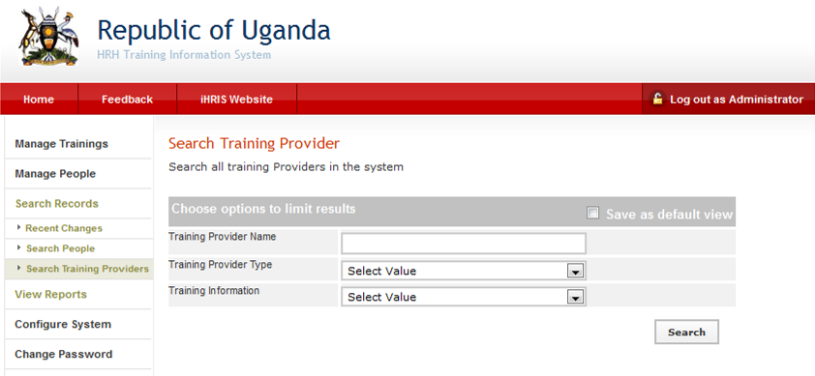
Type the name of a training provider
Type the training provider's name in the appropriate field. Click Search, to get the details and incase the provider does not exit, proceed to add.

Add Training Provider
Clicking on Add a New Training Provider to get the figure below,
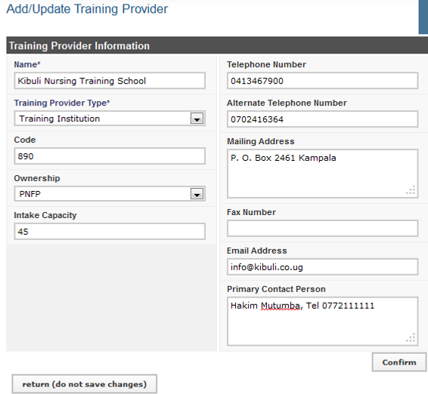
Click here to submit the entered details
Enter the training provider's name, type of training and any contacts in the appropriate fields. Click Confirm, review the information, and save

Add Training
For each training provider, you have to add the different trainings offered. Click on Add Training
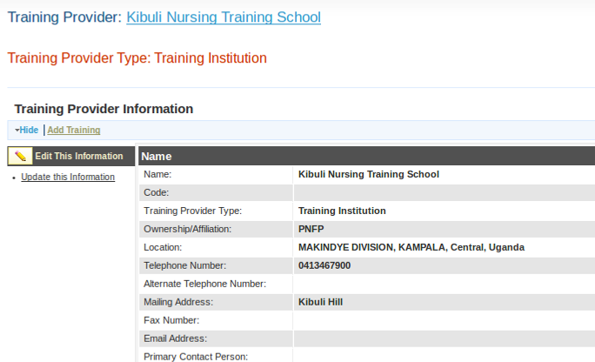
To add a training offer by a training provider
It gives a window below
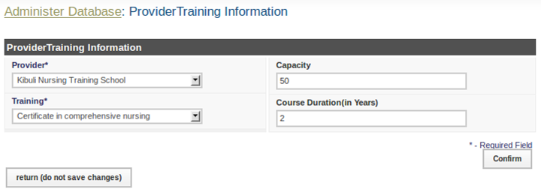
Select training provider and training. Click Confirm, review the information, and save

Schedule training
After adding the training click on View Provider
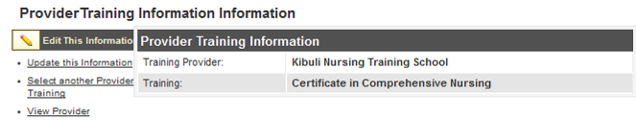
To View Provider Details
This will give you the figure below showing the different trainings the provider offers
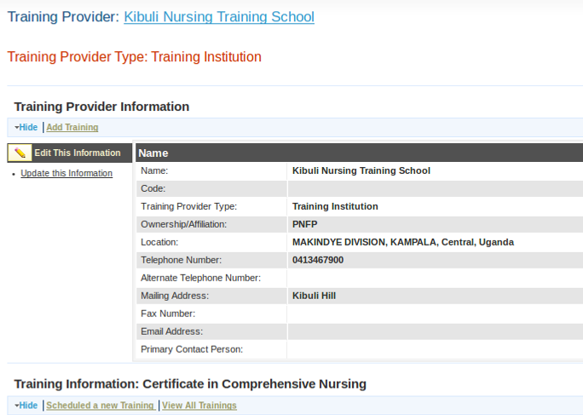
Click here to schedule training
To specify when the training will be taking place, Click schedule a new training to get the screen below
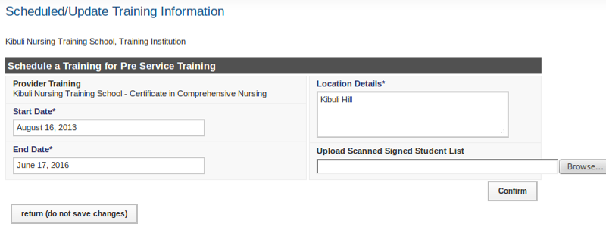
Select the start and end dates and location where the training will take place, confirm and save.

View Trainings
Click on View All Trainings to see all the trainings that training provider is offering
To view the trainings offered
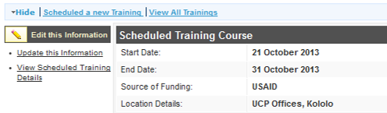

Add participants to training
To add participants/trainees to a specific training, Click of View scheduled training details
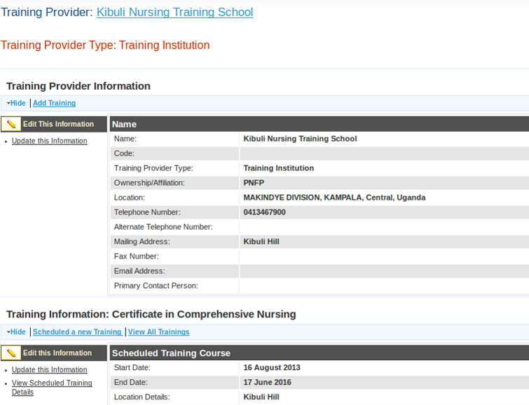
Click here to view scheduled training details
Clicking on View scheduled training details gives figure below. Click on Add Participants
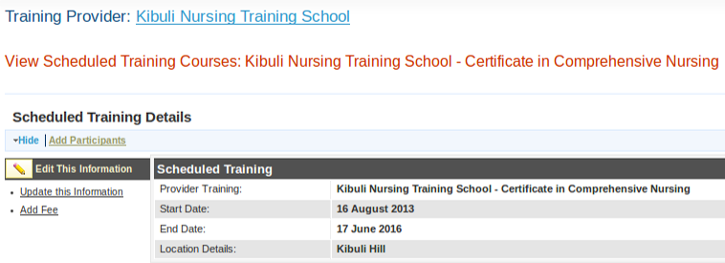
Click here to add participants to training
It gives the screen below used to add participants
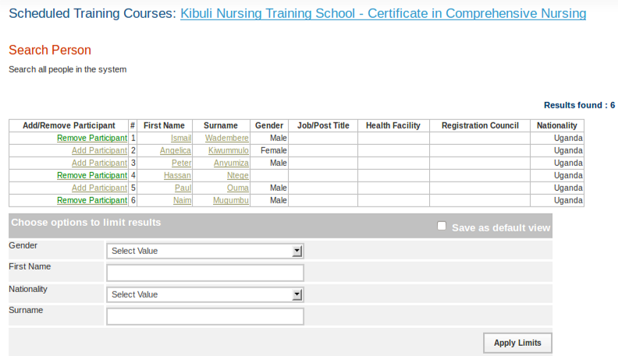
Click here to remove a participant
Click here to add participants to training
On the left of each participant’s record, click Add Participant. When a participant is added, it turns the color to green and the word changes remove participants. To remove a participants from a training click remove participant.

To Add fees
The below the system indicate those who will be attending the training and provision to add fees as below.
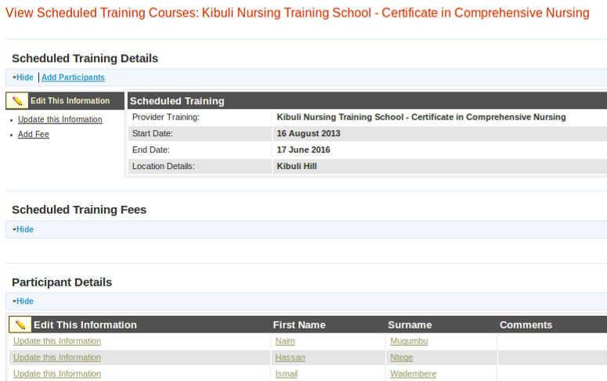
Click here to add fees for training
Participants added to the training
Click on add fees to get
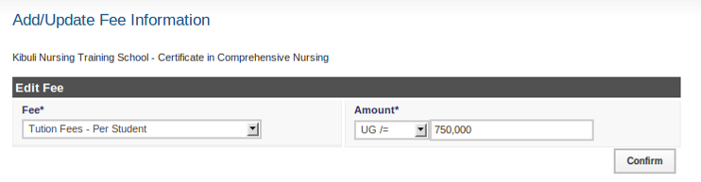
Select the fees type and amount, then confirm and save to get the figure below
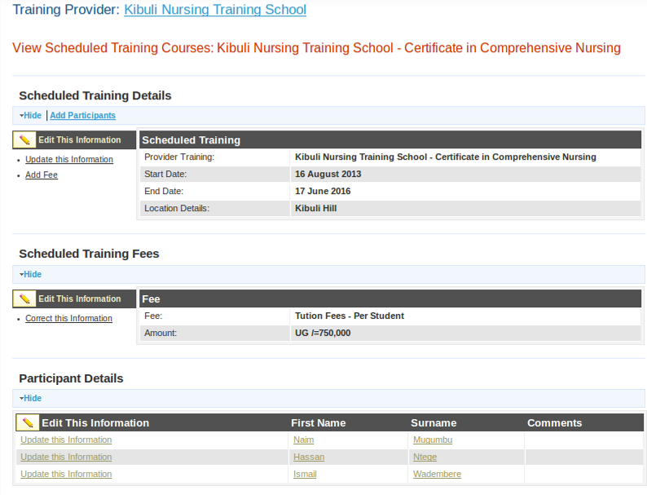

Adding Person to Training via person page
Also participants can be added to training by going to persons page, then clicking on add training
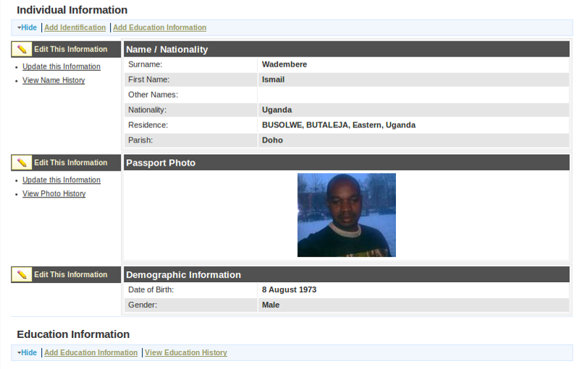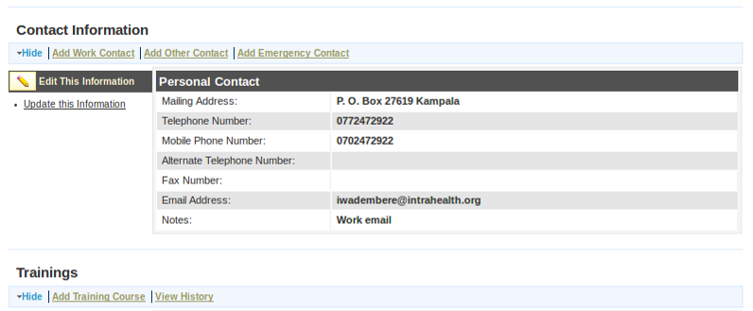
Click to add training
Clicking on add training course gives the screen below to enter the training details
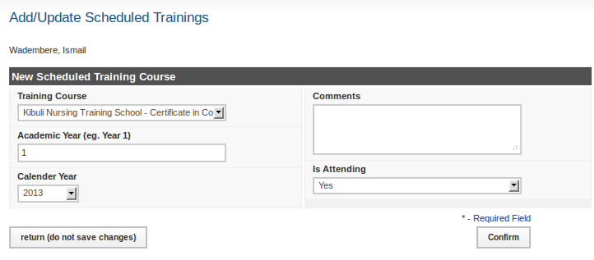

Adding Many Participants to Training from Spread Sheet
To add many participants onto a scheduled training at go, you format the list into a spread sheet like excel. The order of the fields in the spread sheet are as follows (you can use the standard available template):
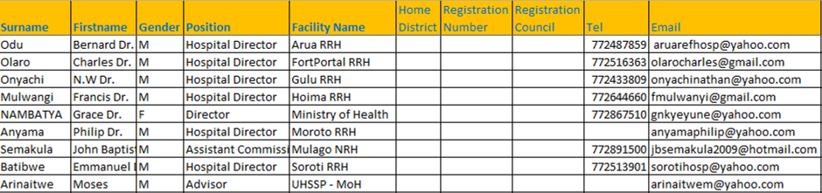
Save the list with file type “csv”. Go to HRIS, search and view scheduled training as explained before. Note: the positions and facility name should have been added to the system via administer database. Click on Upload Participants as shown below.
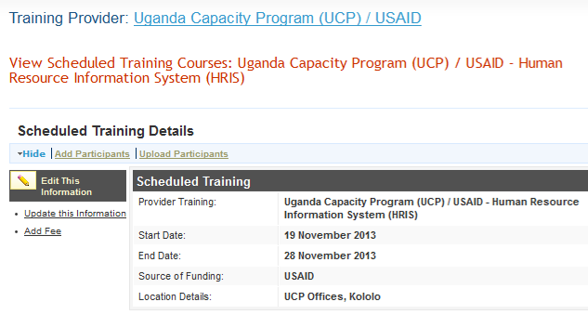
Click upload participants
It gives the window below, and clicks Browse to select the saved CSV file, upload, and click save
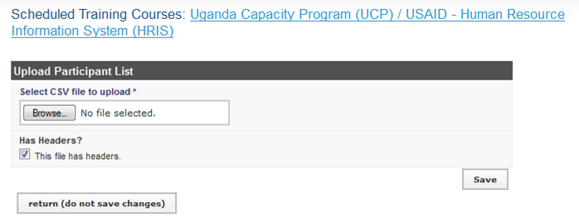
Browse to your computer to pick the CSV file

Search Records
After entering an employee or position in the system, the record may be reviewed at any time.
Click Search Records to locate the record. From the record, additional information can be added or existing information can be updated.
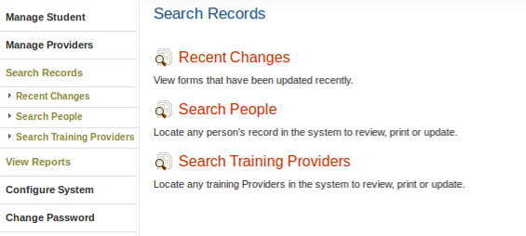

Search People
Click Search People.
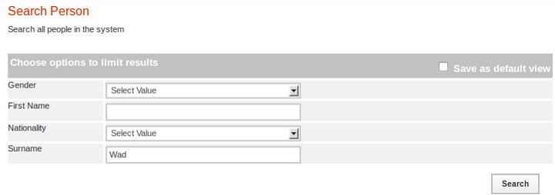
Enter the person's Surname to find a single record or leave blank to find multiple records. For example limit the search to a particular gender by selecting that gender from the Gender menu. Leave blank to search all. Click the search button to show all matching results.
Enter a few letters of the surname and click search
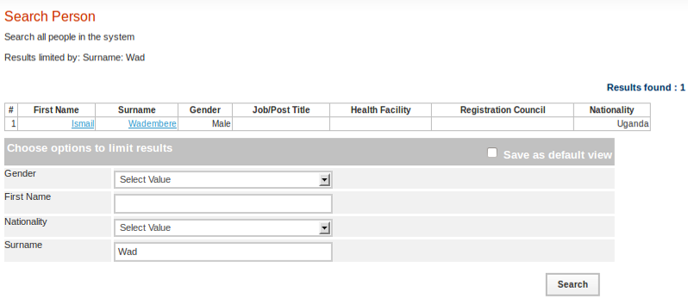
Click on name to show the details
A list of matching records displays. Click the name of the person whose record you want to review. To search again, select new options from the Search form and click search.

Search Training Provider
Click Search Training provider.
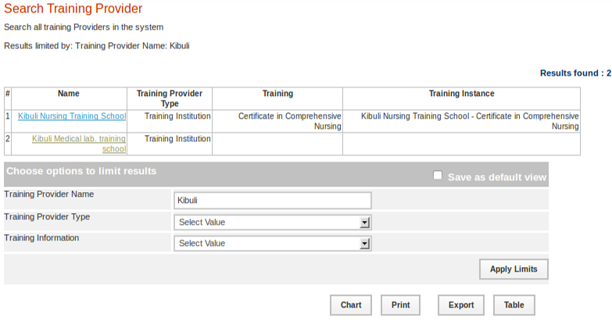
Select one of the options provided at a time to limit the search by training provider name, type, or training information. If an option is not selected, all records will be searched. Click the search button to show all matching results.
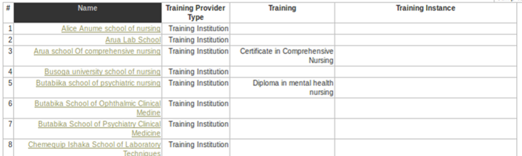
When you click the training provider name, the institution details are displayed including location, contacts, ownership, trainings it offers, and when the training will take place.

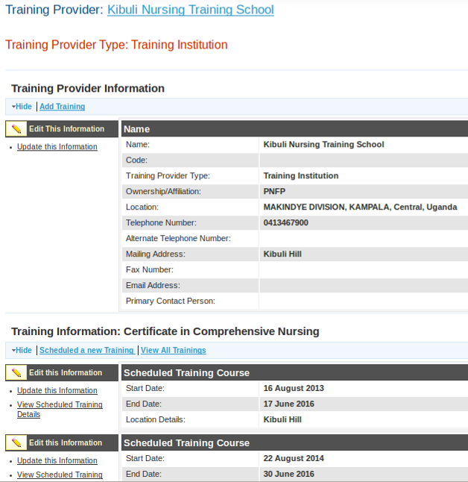
Click to update the information

From this screen, you can update any section by selecting update this information.

Reports
The following pre-defined report views are available once HRIS Train is installed.
- Current Trainees: Shows the students undergoing training in the different institutions with their photos for easy identification.
- Former Trainees: Shows the students who completed training in the different institutions with their photos for easy identification.
- Past Training: It is a list of all trainings which have ever taken place.
- Trainees per Provider: The sums of trainees who attended certain training in different institutions.
- Scheduled/on-going Training Courses: It is a list of Scheduled and On-Going Training Courses in the different institutions
- Pipeline: This column graph displays the total numbers of trainees that have/ are current attending a particular course
- Cadre Output: This pie chart displays the total student output per cadre
- Training Institutions: A List of all training institutions
- Search Person: Search all people in the system
- Search Training Provider: Search all training Providers in the system
To access any report of interest, click View Reports. A list of reports will appear as below.
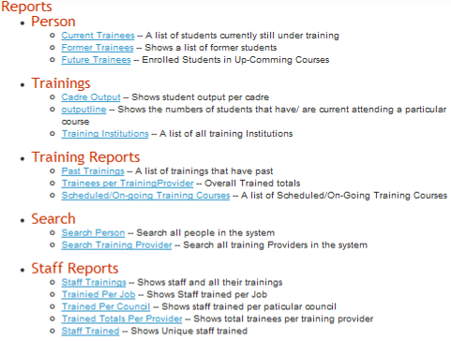

Click the desired report (graphical and table format e.g. Scheduled/on-going Training Course.

Tabular report formats
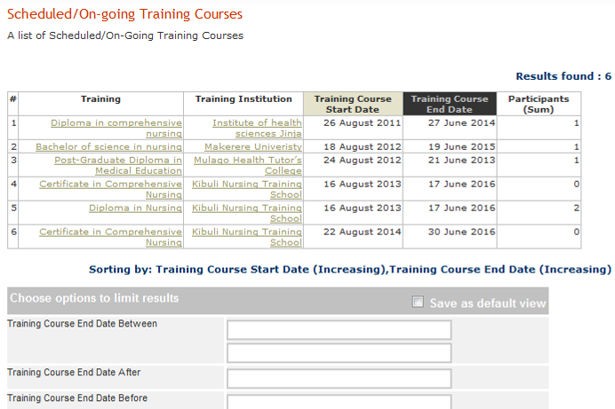

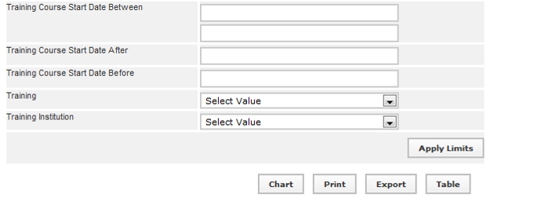
Click to get PDF copy of report
Click to create a graph of the report
Click export to get spread copy of report
To create a pdf file of the above report, click the Print button. To export to spread sheet like excel, click the Export button to get figure below
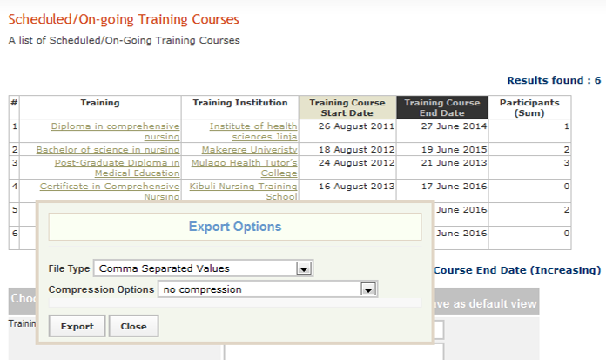
Click export again
Click on export again and no compression, A pop-up windows appears as below, select open with as shown in the screen below
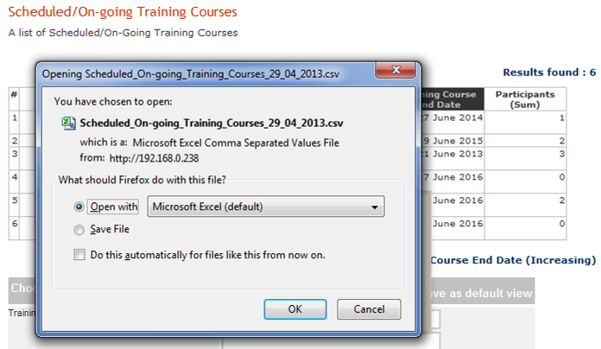
Click the OK button, and the report will be opened in excel.
Note: This file opens or saves as * .CSV. To change the file format, Go to File menu, select Save As, type file name, under save as type choose Excel 97-2003 workbook from the drop down menu

Graphical Report Formats
Follow the previous steps used to display the tabular report format, to get graphical report - clicking Chart button to display summary information in chart format.
Note: The chart function is appropriate for reports with two fields where one field is numeric.
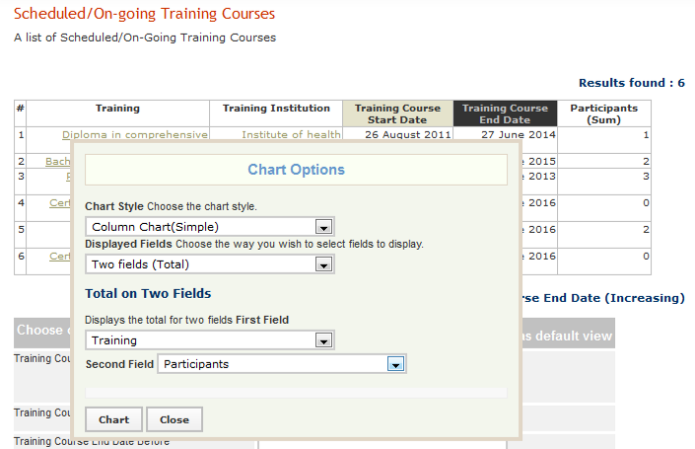
Selection the chart type and display field
Click on chart again to generate it
Choose the desired chart format from Chart Style drop down menu, Choose the way you wish to select fields to display from the Displayed Fields.
Note: Using the procedure above, will help to produce the necessary reports as desired by the user

Report Views
Report views define how data are displayed in a report. Multiple report views can be created for the same report so that data may be aggregated and analyzed in various ways. For each report, data can be displayed either as a table or as a chart. The data may also be exported for further analysis, or the report may be printed.
Administrators and Managers can create new report views or edit views that have already been defined. At least one report view must be defined before a report can be run. Other users may run any report view, but they cannot create new views. Creating report views requires some knowledge of the data fields used in HRIS.
Note: Unless you understand these fields, you should not edit or delete the existing report views pre-defined in HRIS.

Create a new report
To create report views, click Configure System under "Manage Reports” click Report Views.
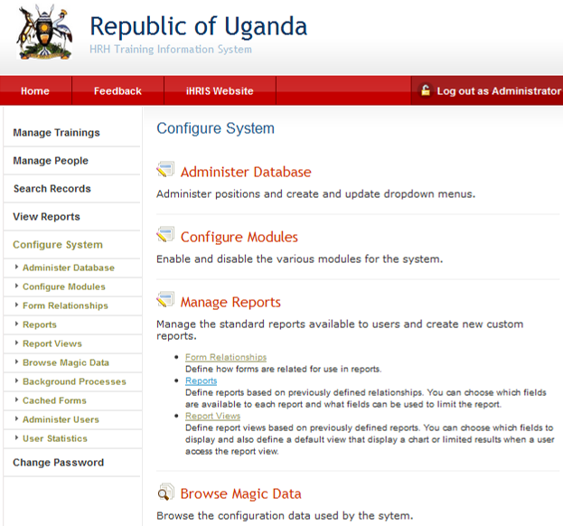
Click report views
Click configure system
Clicking on report Views, gives the window below after scrolling to the bottom
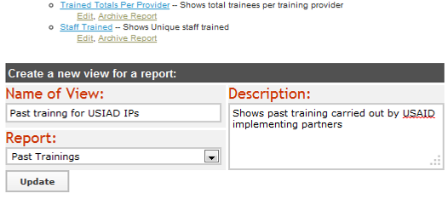
Type the name of the report view, select the affliated report, type a short description of the report view & click update

Type the name of the report view, select the affliated report, type a short description of the report view & click update
The pop up screen displaying the message ‘successfully updated values’ click Close
This is a pop up screen
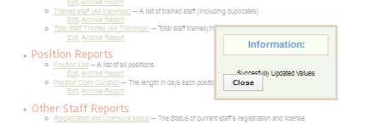

Edit an existing or created report
Note: The following steps also apply to editing an existing report view
Locate the newly created or existing report view and click on edit in order to activate or edit the fields to be seen in the view respectively.
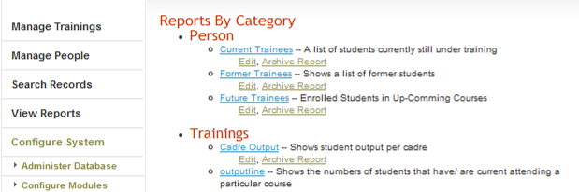
Click Edit
This gives the window below,
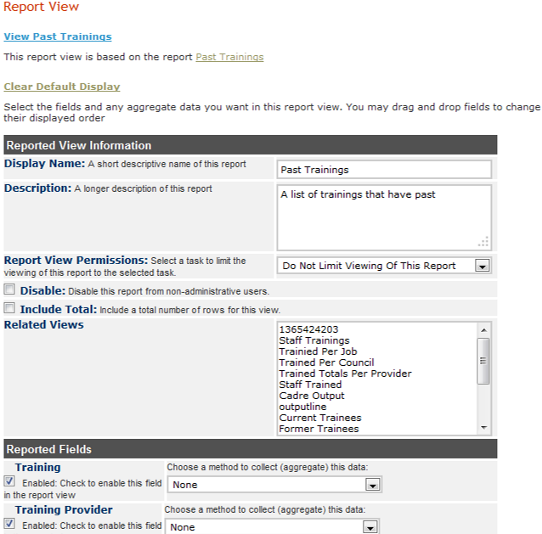
Check box to add a field onto the report
Click in the check box to enable the field
To change order of display of the fields on the report, point on the field name hold and drag to a desired order
After selecting all the desired fields and arrangement, Click Update. The pop up screen displaying the message ‘successfully updated values’ click Close.

Administer Database
To ensure that standard data types such as countries, regions, districts, training types, training courses, institution ownership, and the like are enforced across the system, those standard data types must be created as lists. These lists are used to create selection menus that provide options for selection when adding section of records.
Click Configure System and then click Administer Database to create and update standard lists of data for selection in system menus (see figure below).
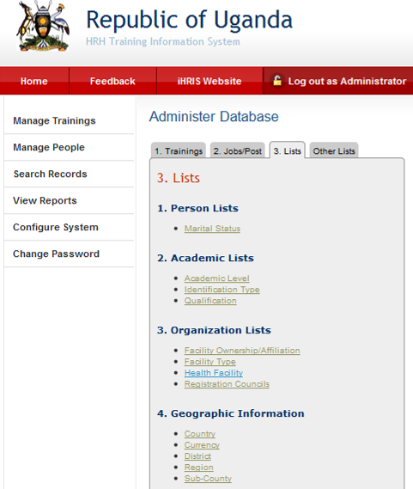
Administer database is composed of several sections i.e. Academic level, Geographic Information, and training information as shown above

Add Academic Level
The academic level classifies a type of educational institution that issues degrees/certification. Academic levels are selected when entering a person's educational history.
Click Configure System then click Administer Database, Click on Education Type/Level. The academic/education Type/Level page opens, showing all academic levels entered in the database.
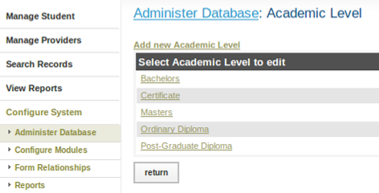
Either Click Add academic level or select an academic level and click Update This Information to edit it.

Add Training Classification/Cadres
A cadre is a broad category of workers characterized by the specific training, certification or other qualifications required to practice or be licensed in that field. Examples of cadres include Nurse, Physician and Pharmacist. Each job can be linked to one cadre for reporting purposes. You may add new cadres or edit any cadre that was previously added.
Click Configure System then click Administer Database, Click on Cadres
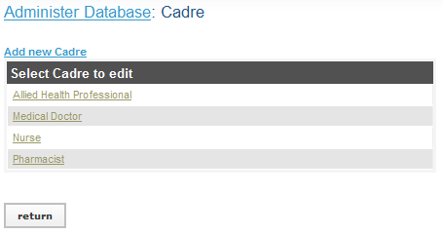
The Cadres page opens, showing all Cadres entered in the database. Either Click Add Cadre or select a Cadre and click Update This Information to edit it.
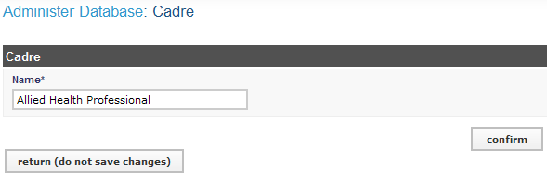
Click Confirm and confirm that the name entered is correct. If it is not correct, click Edit to change it. If it is, click Save to save it.
The same reasoning and steps are used to add or update the rest of the parts of administer database below.
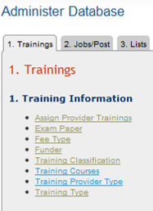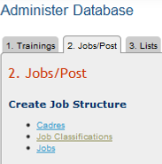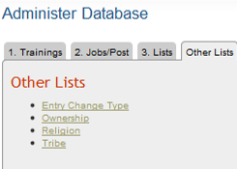

Administering Users

User Roles
There are several types of users for the system with different privileges and access.
- Open access: The public can access the different training provided by training institutions and scheduled trainings available by visiting the HRIS website. No login required.
- Self Service: Every person with details inside HRIS can view their individual details using access given to them by system administrator. They can review entered data and indicate any needed corrections to training manager for updating.
- Executive: Are able to view and search for any information from the system but not to change. The main task being provision of guidance on who should be trained, the training content, and training venue and timing. They comprise of MoES, MoH, district, or hospital leaders who are in charge of HR management or supervision. They include education officer, district health officer (DHO), chief administrative officer (CAO), principle principal officer (PPO), Secretary district service commission (DSC), Training Institution principal, Hospital director, hospital administrator, personal officer (PO), Health Planner, Training planners, heads of programs like Aid, Malaria, and HPCs staff who support and modulate CPD and the training institutions..
- Training Provider: This encompasses anyone who may be giving, organizing or funding trainings e.g. donor, partner, training institution. They are able to add instances of trainings, schedule trainings, add participants to trainings, and log evaluations for the participants and trainings.
- Training Manager: They access anything in the system – duties in addition to all the above include maintaining list of providers, trainings, customizing reports, competencies and facilities.
- System Administrator: The administrator manages the entire system

Add a User
In order to allow a user to access the system, the System Administrator must create a user account for the person, with a unique username and password. Each user is assigned a role, which determines the actions that the user can perform in the system.
On the Home page or left menu, click Configure System then Click Administer Users to create, update and disable user accounts to enforce secure access to the system. Only the System Administrator can add and update user accounts.
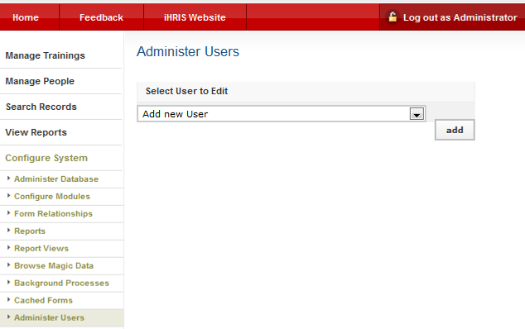
Click here to add a user
Select Add New User from the dropdown menu and click the Add button to get figure
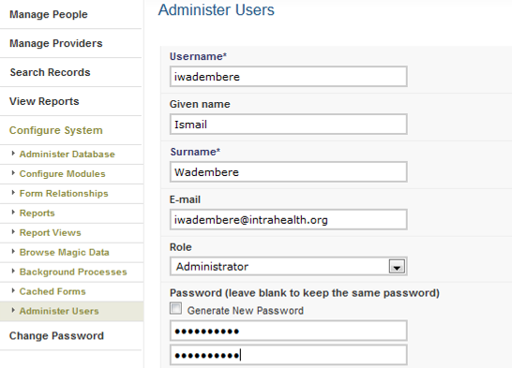

Enter a Username for the user: one word with no special characters (letters and numbers only). Enter the First Name and Surname of the user. Enter an Email for the user, if known (optional). Select the Role of the user. If no role is selected, the user will be disabled and cannot access the system in any capacity.
Enter a Password for the user. Re-enter it to confirm. The two passwords must match.
Click Confirm and verify that the account entered is correct. If it is not correct, click Edit to change it. If it is, click Save to save it.
If an email address was entered, an email message will be sent to the user with the username and password. Otherwise, you will have to provide the user with the username and password.

Self Service
A self-service account can be created for each person whose details have been entered in systems so that they can login to view their details only.
Search for person, display their details and go to the last section – self-service and click on Add User Account get the window below
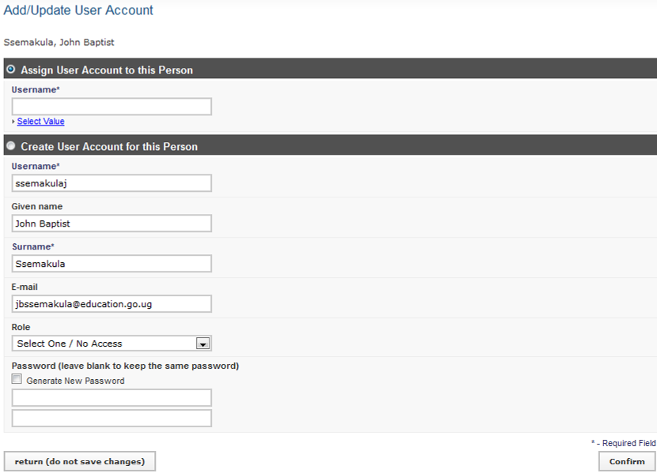
Enter the data in the appropriate fields. Click Confirm, review the information, and save

Update a User
To change user information, click Configure System and then Click Administer Users.
From the drop down menu select the user account to change.
Update the user account (change passwords, account type, or disabled account

Change Your Password
At any time, you can change your password for logging into the system. Click Change Password.
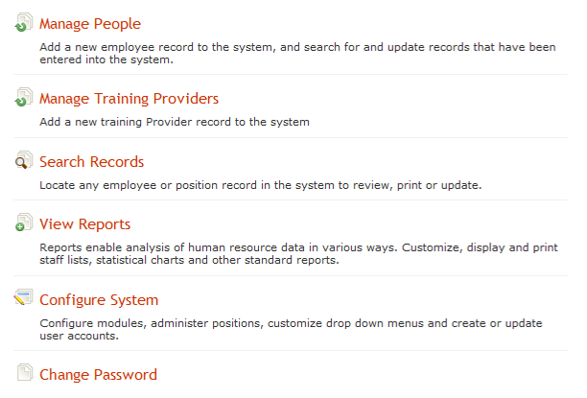
Click here to change password.
Clicking on change password, you get figure below
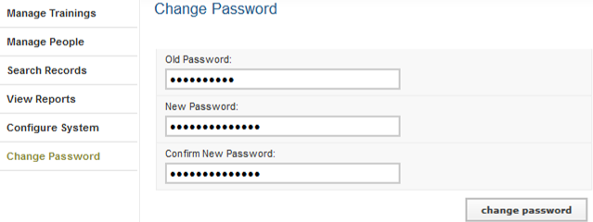
Enter your Old Password (current password). Enter the desired New Password. Re-enter the new password under Confirm New Password to confirm it. Click Change Password. This will reset to the new password.

Retrieve a Forgotten Password
Contact system administrator in case you have forgotten your password or username OR From the Log In page, click Forgot username or password?
To reset the password, enter your Username in the box next to "Reset Password" and click the Reset button. The system will email your new password to you
To recover your username, enter your Email Address in the box next to "Display Username" and click the View button. The system will display your username.
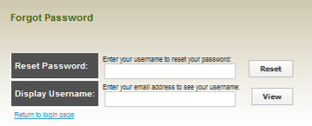
Click the link to Return to login page and log in as normal

Log Out
When you are finished working in the system, log out to prevent any unauthorized person from accessing the system. In the upper left corner on any page, click Log out (next to the padlock).
Click log out

