iHRIS Operations Guide

Operations guide to the Malawian implementation of iHRIS within the Ministry of Health.
The Malawian Implementation
Herman Fung 2014

Contents
2. Introduction 1
3. Support Mailbox and Hotline 1
iHRIS Support Placard 2
4. Support Rota 2
5. Daily Health Checks 3
6. File Library 3
Dropbox 3
Huddle 4
Files 5
Meetings 6
People 6
Settings 6
7. Subversion (svn) 6
8. Launchpad 7
9. Environments 7
10. CHSU 8
Datacentre 8
Server 8
Asset identification 8
Server Name 9
Hardware 9
Software 9
Configurations 9
SSH 9
Daily Backups 11
Grive 11
Scripts 11
Other 12
11. iHRIS User Accounts 12
Roles 12
New Users 13
12. Global iHRIS Community 15

Introduction
iHRIS for the Ministry of Health Malawi became operational on 31st January 2014.
This document is a reference guide to the various operational requirements and arrangements to support iHRIS on an ongoing basis.
For the purposes of this document, the "Technical Team" refers to the Development and Support Teams, which include VSO volunteers and IT Officers from the Ministry of Health, who are part of the project.

Support Mailbox and Hotline
ihrismalawi@gmail.com is the central, shared mailbox for the Technical Team.
This is where all enquiries, new iHRIS user requests and feedback are received.
- Go to https://mail.google.com/
- Log in
  - as ihrismalawi, or
  - a delegated account
    - Click on your personalised Google icon in the top right corner
    - Select ihrismalawi@gmail.com (delegated)
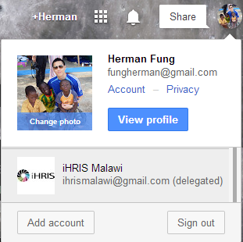
To administer sharing/delegation:-
- Log in as ihrismalawi
- Click on the gear icon near the top right corner of the page
- Select Settings
- Select the Accounts tab
- Manage the "Grant access to your account" section as required
- When an account is added, the invitation must be accepted before access is active
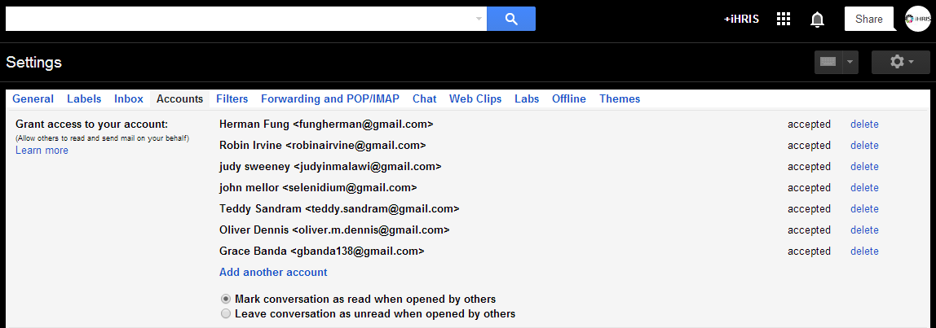
There is also a telephone hotline for more urgent support queries and requests.
Management of the mailbox and hotline telephone is the responsibility of the person as identified in the Support Rota.

iHRIS Support Placard

Web Address: | ihris.health.gov.mw
Support Hotline: | 0993848710
Email: | ihrismalawi@gmail.com

Support Rota
The Support Rota is a weekly schedule used to share the responsibility of managing the Support Mailbox and Hotline, and perform the Daily Health Checks.
It also identifies which team member has the MTL WiMAX Router for out of hours use.
- Dropbox: iHRISshare\Operations\Support Rota.xlsx

Daily Health Checks
Every morning of each working day, a basic set of tests or health checks should be conducted in Production (see Environments) to ensure the system is up and running, ready for all users.
The team member responsible is identified in the Support Rota.
- Access the Production system: http://ihris.health.gov.mw/
- Log in as any user
- Complete a person search
- View a person
- Open the Staff Report
- Log out

File Library
There are 2 official tools used to store documents and other files relevant to the project:-
- Dropbox
- Huddle

Dropbox
Dropbox is a file sharing tool, used by the Technical Team on a daily basis.
A master account, owned by ihrismalawi@gmail.com, store the files required for easy and quick access. For example, this iHRIS Operations Guide.
A shared folder called iHRISshare is used to synchronise files for multiple users within the Development and Support Teams. This enables access to important files even when the users are offline because a copy of the files are stored on the users' local computer and it is kept up-to-date.
- Access Dropbox website: https://www.dropbox.com/
- Log in as ihrismalawi@gmail.com
  - To administer access to iHRISshare,
  - Select the iHRISshare folder and click on Shared folder options… to set up and manage permissions
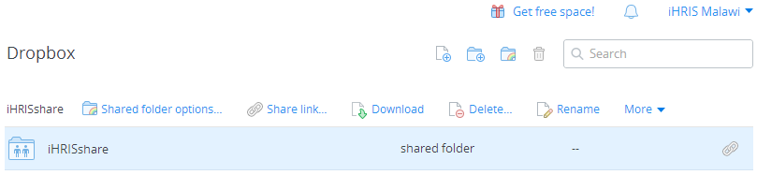
- Each user must accept their invitation.
- Each user should have the Dropbox client program (available for Windows, Ubuntu and Mac) installed.
  - Go to Preferences. Check the Enable LAN sync option.
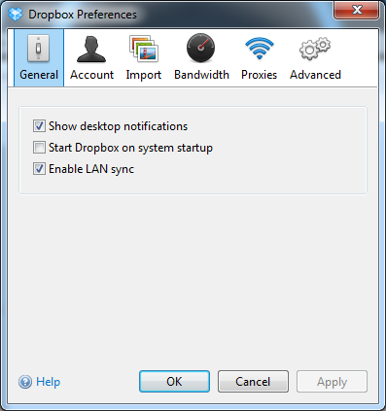
Where users of iHRISshare are on the same LAN, the synchronisation will be significantly faster.
Alternatively, users can access the Dropbox website to download and upload the required files when necessary.

Huddle
Huddle is the client facing project management tool, where information is shared with all stakeholders.
- Access Huddle: https://my.huddle.net/
- Log in using an authorised account (email address or username)
- Choose the iHRIS Project Workspace
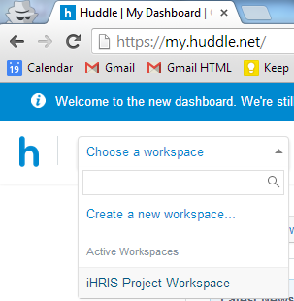
There are various features in Huddle, displayed as tabs near the top right corner of the page:-
- Overview
- Files
- Meetings
- People
- Settings

Files
This is where all published documents are stored. This differs to the purpose of Dropbox, which should be used for working documents required by the Technical Team only.
Huddle has more advanced access controls. It can be used to restrict access to certain audiences only. For example, the Ministry of Health team, as defined in the People feature.
- Go to the relevant folder
- Click on the Edit access permission on the right hand side of the page
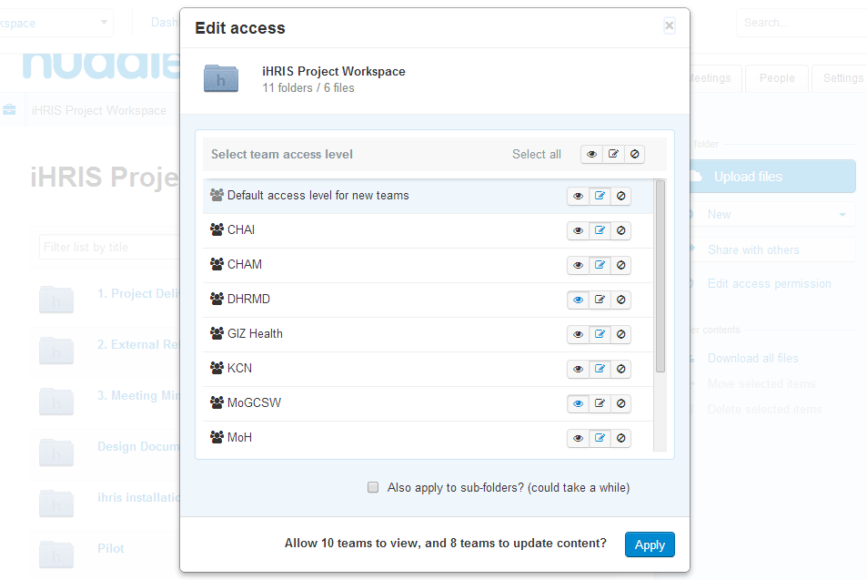
Members of the Technical Team should download the Huddle for Windows or Huddle for Mac client program. This enable desktop integration with the Huddle file library. Allowing the user to:-
- Open in relevant application e.g. Word
  - Edit and lock, or
  - Open read-only
- Make changes in relevant application
- Save
- Close
  - Keep locked, or
  - Unlock it for other users to update
    - N.B. Workspace managers can override locks by clicking on the padlock icon
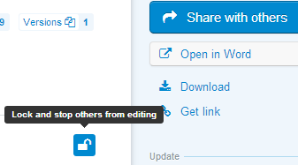
The alternative is to Download the latest version of the file each time. Edit the file. Then Upload new version manually.

Meetings
This is a simple calendar feature. Use this to record events pertinent to all stakeholders.

People
This is a directory of all users who have access to the workspace. Use this to find stakeholders' contact details and organise them into teams.

Settings
This is the control panel of the workspace. It is only available to workspace managers. Use this to organise teams, revoke users, reissue invitation to new users, turn features on or off.
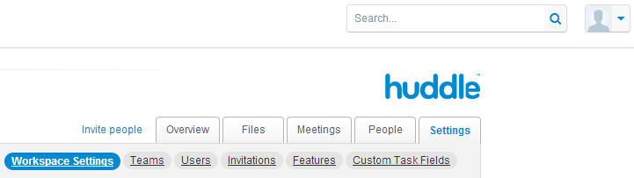

Subversion (svn)
Subversion is a software versioning and revision control tool. The SVN repository is where the iHRIS Malawi source code is stored. It is located on the CHSU Server.
- Repository location: /ihris/grive/svn/repo
  - Symbolic link: /ihris/svn (for web access)
- Project name: ihris-moh-malawi
The repository is secured and requires all users to have a username and password to read or write to its content.
Access to the repository is a administered using the htpasswd command on the file /etc/apache2/dav_svn.passwd. Login to the server, run:-
- To add a new user or edit current a user's password
  - sudo htpasswd /etc/apache2/dav_svn.passwd username
    - e.g. sudo htpasswd /etc/apache2/dav_svn.passwd herman
  - Enter and confirm new password for user
- To remove a user; Edit the access file:-
  - sudo vi /etc/apache2/dav_svn.passwd
  - Remove the relevant line for the user
Notes:-
- A web interface of the iHRIS Malawi code is available at http://ihris.health.gov.mw/svn/
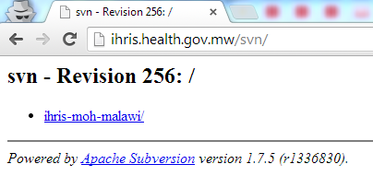
- Basic svn commands: http://svnbook.red-bean.com/en/1.6/svn.ref.svn.html

Launchpad
Launchpad is a software development project hosting site. Together with the Bazaar (bzr) revision control tool, it is part of the recommended toolset for iHRIS projects.
Since Subversion (svn) is the main revision control tool for iHRIS Malawi, Launchpad is only used to publish source code which has been packaged into a release. For example, Release 1.0.
- URL: https://launchpad.net/ihris-moh-malawi
Access to the project is administered through Launchpad itself.

Environments
There are 5 iHRIS environments, which are hosted from the CHSU Server:-
- Private
  - Production
    - /var/lib/iHRIS/sites/manage
  - Pre-production
    - /var/lib/iHRIS/sites/manage-preprod
  - Training1
    - /var/lib/iHRIS/sites/training1
- Public
  - Demo1
    - /var/lib/iHRIS/sites/demo1
  - Demo2
    - /var/lib/iHRIS/sites/demo2
Production, Pre-production, Training1 are for internal use, within the project and stakeholders. The databases will have live data.
Demo1 and Demo2 are intended for demonstration use to wider observers of the project and to the public. For example, other iHRIS projects and developers. As such, the databases should only include test data. The code base for each environment can change depending on the use. For example, Demo1 = Production, Demo2 = Pre-production level.

CHSU
CHSU is an acronym for the Community Health Sciences Unit.
It is a satellite office of the Ministry of Health Headquarters, located in Area 3, Lilongwe.

Datacentre
The CHSU Datacentre is located within Room 15 of the HIV and AIDS Department building.
The iHRISshare Dropbox folder contains all information relevant to the datacentre.
- Dropbox: iHRISshare\CHSU\CHSU Datacentre.xlsx
  - Contacts worksheet
  - Asset Register worksheet
In case of suspected site outages, use the Contacts worksheet to ascertain the 1st Line Support contacts.
Keeping the Contacts and Asset Register up-to-date is the joint responsibility of the iHRIS Technical Team and 1st Line Support.

Server

Asset identification
- iHRIS/Server/01

Server Name
- ihrisprod01

Hardware
- HP ProLiant DL360p Gen8
- Intel Xeon E5-2640 (2.5GHz/6-core/15MB/95W)
- HP 4GB (1x4GB) Single Rank x4 PC3L-10600R (DDR3-1333) x 6
- HP 160GB 6G SATA 7.2K rpm SFF (2.5-inch) SC Midline 1yr Warranty Hard Drive x 3
- HP 1TB 6G SATA 7.2K rpm SFF (2.5-inch) SC Midline 1yr Warranty Hard Drive x 3

Software
- Ubuntu 13.04 (GNU/Linux 3.8.0-34-generic x86_64)
- Apache2
- MySQL
- PHP
See iHRIS Wiki for more information: http://www.ihris.org/wiki/Linux_(Ubuntu)_Installation_-_4.1.8

Configurations
- Top level URL: http://ihris.health.gov.mw/
  - Designated IP address: 41.87.6.123
- RAID 5 disk configuration:-
  - Disk /dev/sda: 293.6 GB: All non iHRIS files, including Software
  - Disk /dev/sdb: 2000.3 GB: All iHRIS files, under /ihris
- Postfix SMTP via Gmail (see http://rtcamp.com/tutorials/linux/ubuntu-postfix-gmail-smtp/) using ihrismalawi@gmail.com

SSH
SSH stands for Secure Shell. It is used to remotely login and control the server.
- In Windows, use PuTTY (Dropbox: iHRISshare\Tech Support\putty\PUTTY.EXE)
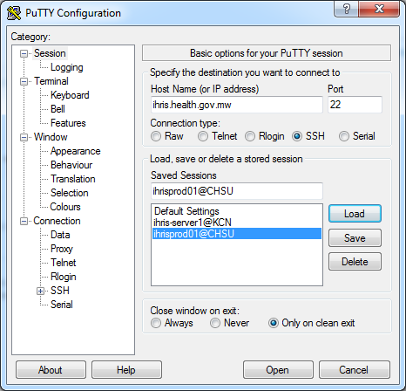
- In Ubuntu, use the native Terminal
  - Run: ssh ihris@ihris.health.gov.mw
Access to the server is secured by keys, as opposed to username/password. Each user's computer must have an authorised key to access the server via SSH.
The private key is stored on an user's machine. While its paired public key is stored on the server ("host").
The list of all authorised keys is stored in a file on the server:-
- /home/ihris/.ssh/authorized_keys
See this tutorial on administering SSH keys:-
- https://help.ubuntu.com/community/SSH/OpenSSH/Keys
When a new user requires access to the server, follow the tutorial to generate a public and private key pair. Then grant access by inserting the new user's public key into this authorised keys file on the server.
- Log in to the server (from an authorised user's machine)
  - ssh ihris@ihris.health.gov.mw
- Open the authorised keys file
  - vi /home/ihris/.ssh/authorized_keys
- Paste in the new user's public key into a single line (i.e. no carriage returns)
- Save the file
  - Press <ESC>
  - :wq

Daily Backups
A backup of the Production database is scheduled every day at 18:00, using cron.
To edit from server command prompt:-
- crontab -e
- Amend the following lines or add new lines:-
0 18 * * * /home/ihris/bin/dbbackup.sh
0 1 * * * cd /ihris/grive/ && grive > /dev/null 2>&1

Grive
Grive is an open source Linux client for Google Drive. It is used as the offsite, cloud backup solution for database backups and important files, including the Subversion (svn) repository.
When grive is executed, it synchronises all the contents of its folder to the ihrismalawi@gmail.com Google Drive account.
- Grive directory: /ihris/grive/
- Google Drive URL: https://drive.google.com/
To execute grive, go to the Grive directory and simply enter grive.
Note: Grive release 0.3.0 (see readme: https://github.com/Grive/) does not support symbolic links. So the files requiring backup must be located in the grive directory. Where necessary, create a symbolic link from its intended location to its location under /ihris/grive/, using the ln -s command.

Scripts
Custom scripts directory: /home/ihris/bin/scripts/
(Symbolic linked to: /ihris/grive/scripts)
- dbbackup.sh
  - Creates new dump of the Production (ihris_manage) database
  - Removes old dumps, older than 7 days
- lamp_restart.sh
  - Restarts Apache2 and Memcached
- rebuild_environment_quick.sh
  - User must specify which environment to rebuild e.g. demo1
  - Drop all tables, cycle webserver, perform site update, import quick dataset from csv files
- rebuild_environment.sh
  - User must specify which environment to rebuild e.g. training1
  - Drop all tables, cycle webserver, perform site update, import full dataset from csv files

Other
- Apache2:-
  - Web server root directory: /var/www/
  - /var/log/apache2/error.log
  - /var/log/apache2/access.log
- phpMyAdmin URL: http://ihris.health.gov.mw/phpmyadmin/
- Link to basic Unix commands: http://mally.stanford.edu/~sr/computing/basic-unix.html
- Other useful commands:-
  - top - Displays top CPU processes and some system monitoring information
  - uptime - Displays the current time, how long the system has been running, how many users are currently logged on, and the system load averages for the past 1, 5, and 15 minutes.
ihris@ihrisprod01:~$ uptime
15:34:34 up 3 days, 22:56, 1 user, load average: 0.05, 0.19, 0.17

iHRIS User Accounts

Roles
There are 3 roles for all users:-
- Administrator
  - Restricted to Technical Team members only.
- Executive Manager
  - Read-only users. Mainly report users.
- Geographic/Facility Access
  - HR Officers of each Cost Centre and managers of that particular dataset.
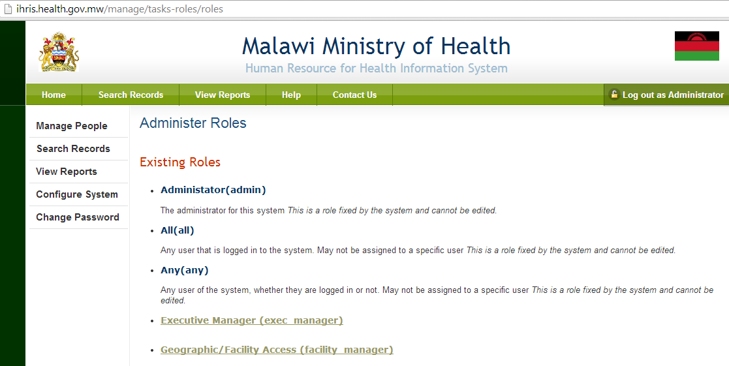

New Users
All requests for new iHRIS users (in Production) should be sent to the Support Mailbox, where possible. So there is an audit trail. If it is part of a national rollout training session, then no email is required.
All request should include the following information on the new user:-
- Given name
- Surname
- Email address
- Job, location and approval (where necessary)
Upon receiving complete requests, an administrator should:-
- Log in to the required environment
- Go to Configure System > Administer Users
- Select Add a new user
- Fill in the relevant fields
  - Following the convention of first initial and surname for all username e.g. hfung for Herman Fung
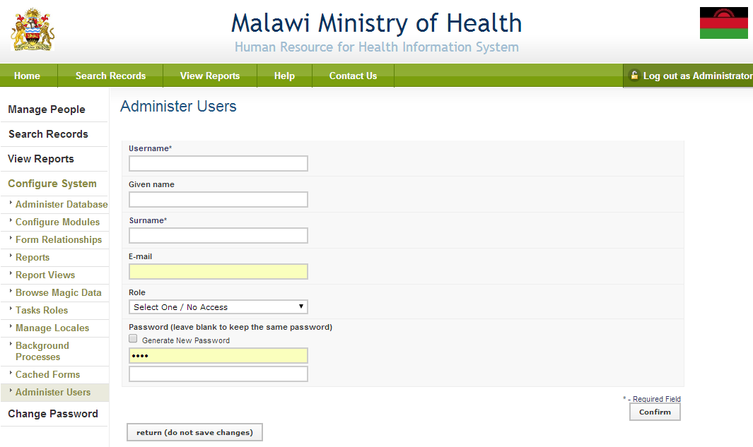
- Ensure a valid email address for the user is entered, where possible.
The user's email address is used for the Forgot Password functionality.
  - If an email address has been provided, check the Generate New Password option.
  - If not, manually enter in a password.
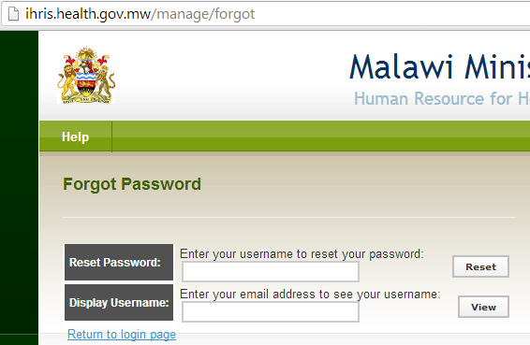
- Select the relevant Role
- Click <Confirm> and <Save>
- If the Role was Geographic/Facility Access, add their location facility
  - Click Add Facility/Location
  - Select the required Cost Centre from the drop down menu
  - Click <Confirm> and <Save>
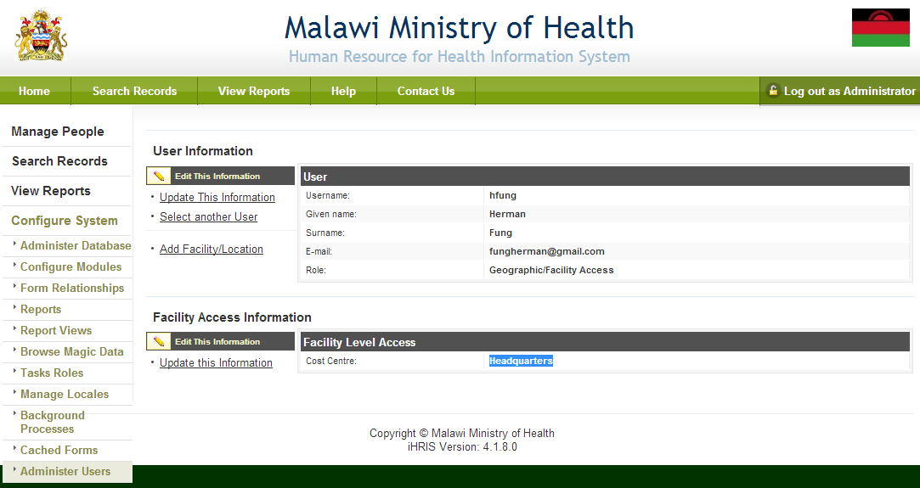
- Reply to the request, stating the username
  - If an email address has been provided, instruct the user to use the Forgot username or password option to reset their own password.
  - If no email address has been provided, communicate the password by other channels e.g. internal memo

Global iHRIS Community
The organisation (Intrahealth) and project (CapacityPlus) behind the iHRIS software have set up a public Google Group, called the Global iHRIS Community.
As well as the iHRIS Wiki (http://wiki.ihris.org/), this is an additional source of knowledge on the software and implementations around the world. It is also where iHRIS Malawi can share information with other countries and projects.
The group has technical and non-technical discussions.
- URL: http://groups.google.com/group/ihris

